Please complete this form, add your electronic signature and send it by email to Rumena.Begum@rcm.org.uk or print and sign it and ensure that it is received by Rumena Begum, Membership Services Officer at The Royal College of Midwives, 15 Mansfield Street, London W1G 9NH by 8 April 2019.
To avoid losing information you are advised to save this form before you enter any information.

Your forenames
Your surname
Your NMC pin number)
(only applicable to Midwives)

Your RCM membership number
Your postal address

Your home ‘phone
Your work ‘phone
Your mobile ‘phone
Your Email

Declaration

I nominate myself for election as a member of the RCM Board and declare as follows.
    - I am a full member of the RCM (Midwife or Maternity Support Worker) and on the date of commencement of the office for which I am nominating myself I will have been a full member of the RCM for at least three years.

    - As a Midwife, I am compliant with the revalidation requirements.

      - I have provided the election documents required by the Rules of the RCM in order that I may stand as a candidate for election to the RCM Board.

    - I give consent for the RCM to carry out relevant checks including, if necessary, identity checks, Criminal Records Bureau (or relevant country equivalent) disclosures and checks against lists of removed or disqualified trustees held by a regulator of charities in the UK.

    - If appointed as a Trustee I will undertake to accept appointment as a trustee of the Royal College of Midwives Trust.

    - I undertake to fulfil the responsibilities and duties of the Office for which I am a candidate in good faith, in accordance with the law and in accordance with the Codes of Conduct for members of the RCM Board and Trustees of the RCM Trust.

    - I have obtained undertakings from my employer regarding time off to undertake the duties of the Office for which I am seeking election or I am prepared to commit my own time for those duties.

    - I have not been expelled from the RCM Board for breach of the RCM Board’s Code of Conduct.

    - My professional conduct is not under investigation by the Nursing and Midwifery Council.

    - I am not employed by, or a member of, any organisations which are competitors of the RCM in the field of professional or trade union representation.

    - I am not an undischarged bankrupt or subject to any arrangement or composition with creditors generally.

    - I have not, by a Court or a statutory regulator of charities in the UK, been removed or disqualified from trusteeship of a charity.

    - I am not disqualified by virtue of any provision of the Companies Acts or prohibited by law from being a company director.

    - I have not been convicted of an offence involving deception or dishonesty (unless the conviction is spent).

    - I am not disqualified under the Charities Acts from acting as a charity trustee.

    - I am not an employee of the RCM.

    - I am not subject to court orders because my mental health prevents me from personally exercising any powers or rights which I would otherwise have.

I consent to share the information on this form with those in the RCM responsible for the assessment process and those working on the RCM’s behalf. I understand that information I have given on this form will be handled in line with the Data Protection Act 1998 and will be used solely for the purposes of assessing my eligibility and competency for this role. The information given on this form is complete and correct. I understand that if any of the information provided is untrue I may be removed from office without notice.

Signed ………………………………………………………………………………………………

Dated ……………….

For monitoring purposes only, please also complete the attached Equality and Diversity Monitoring Form.

Royal College of Midwives Equality and Diversity Monitoring Form
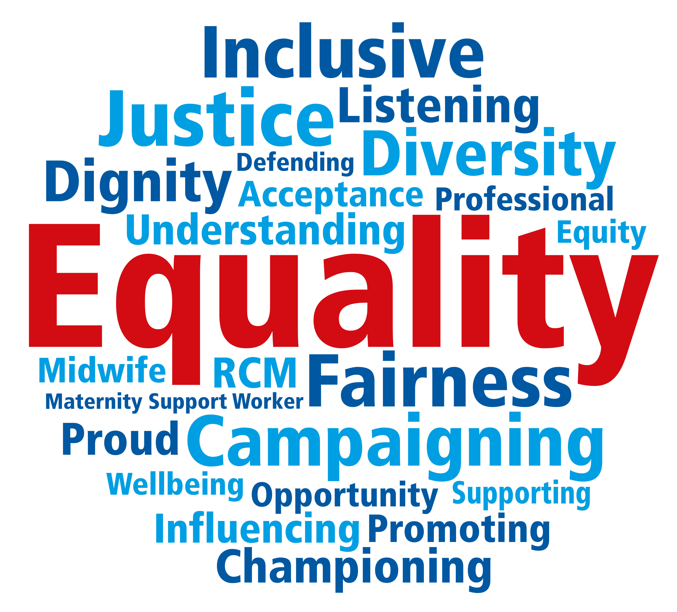
The Royal College of Midwives (RCM) is committed to equal opportunities and reflecting the diversity of our membership.
To ensure effective implementation of our equality and diversity policy we ask you to complete answer the following 5 questions.
Please be assured that forms are anonymous and will be considered separately to your application.

- Please indicate your sex/gender

☐ Female
☐ Male
☐ Prefer not to say

- Please indicate your ethnic group (options are listed alphabetically)

☐ Arabic or Arabic British
☐ Asian or Asian British - Bangladeshi
☐ Asian or Asian British - Chinese
☐ Asian or Asian British - Pakistani
☐ Asian or Asian British - Other
☐ Black or Black British - African
☐ Black or Black British - Caribbean
☐ Black or Black British - Other
☐ Mixed - White and Asian
☐ Mixed - White and Black African
☐ Mixed - White Black Caribbean
☐ Mixed - Other
☐ White - British
☐ White - Gypsy or Irish Traveller
☐ White - Irish
☐ White - Other
☐ Other Ethnic Group
☐ Prefer not to say

- Do you consider yourself to have a disability or long term health condition? (Disability is legally defined as a ‘physical or mental impairment which has substantial and long term adverse effect on a person’s ability to carry out normal day-to-day activities).

☐ Yes
☐ No
☐ Prefer not to say

- Please indicate your age band

☐ Under 21
☐ 21-30
☐ 31-40
☐ 41-50
☐ 51-60
☐ 61-65
☐ Over 65
☐ Prefer not to say

- Please indicate your sexual orientation (options are listed alphabetically)

☐ Bisexual
☐ Gay Man
☐ Gay Woman/Lesbian
☐ Heterosexual
☐ Other
☐ Prefer not to say

Thank you for taking the time to complete this form.

